# Description

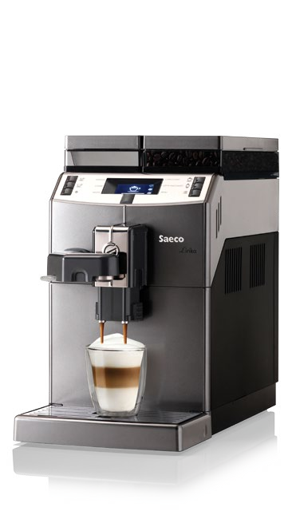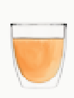

**O**

**G**

**A**

**T**

**I**

**O**

**N**

**P**

**R**

**O**

**F**

**E**

**S**

**S**

**I**

**O**

**N**

**A**

**L**

**H**

**O**

**M**

**O**

**L**

Lirika is a simple, compact and performing machine, ideal for the office and small Ho.Re.Ca. venues.

It has modern and essential lines, high capacity water and coffee tanks and is incredibly easy to use.

Lirika, Lirika Plus and Lirika OTC are the best expression of Saeco know-how, in three versions that offer a concentrated mix of top quality and performance.

The wide display (in the OTC version with completely redesigned icons) allows the user to choose espresso or coffee and hot water or steam delivered through an independent wand (steam not available in the OTC version).

They can also prepare creamy and tasty cappuccinos and latte macchiato, also with the “One Touch“ system in Lirika OTC, thanks to the innovative “Pinless Wonder“ cappuccinatore.

All the models are characterised by the pre-brewing system, a Class A boiler, ceramic blades and a removable brewing unit (with aroma intensity calibration in the OTC and Plus versions), to facilitate cleaning and maintenance activities.

# Main features

* One-Touch Cappuccino (OTC version)
* Saeco brewing unit, with adjustable strength (OTC and Plus versions)
* State of the art interface: 3 colours graphic display (2 colours in the OTC version) with clear buttons
* Extensive programmation menu, easy to be set
* Professional homologation
* High capacity: 2,5 l water, 500 gr coffee beans
* Very slim (only 21.5 cm wide)

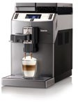

**Technical data Lirika** OTC

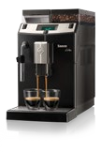

**Lirika**

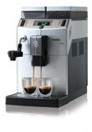

**Lirika** Plus

**Structural specifications**

|  |  |  |  |
| --- | --- | --- | --- |
| Dimensions (w x h x d) | 215 x 370 x 429 mm | 215 x 370 x 429 mm | 215 x 370 x 429 mm |
| Weight | 8 kg | 8 kg | 8 kg |
| Colour | dark grey | silver / black | black |
| Chassis | painted ABS with metal grid | painted ABS with metal grid | ABS with metal grid |

**Electrical specifications**

|  |  |  |  |
| --- | --- | --- | --- |
| Power supply | 220-240 V/50-60 Hz | 220-240-120 V/50-60 Hz | 220-240-120 V/50-60 Hz |
| Absorbed power | 1850 W | 1850 W | 1850 W |

**Water specifications**

|  |  |  |  |
| --- | --- | --- | --- |
| Boiler material | stainless steel | stainless steel | stainless steel |
| Hydraulic system | single circuit | single circuit | single circuit |
| Hot water / steam wand | dedicated hot water wand (no steam) | with Tuono | with pannarello |
| Pump pressure | 15 bar | 15 bar | 15 bar |

**Water connections**

|  |  |  |  |
| --- | --- | --- | --- |
| Water supply | independent tank | independent tank | independent tank |
| Water supply connection | no | no | no |

**Capacities**

|  |  |  |  |
| --- | --- | --- | --- |
| Coffee beans container | 500 gr | 500 gr | 500 gr |
| Water tank | 2.5 l, removable | 2.5 l, removable | 2.5 l, removable |
| Coffee grounds capacity | 15 | 15 | 15 |

**Other specifications**

|  |  |  |  |
| --- | --- | --- | --- |
| Cappuccinatore | Pinless Wonder, completely automatic | Tuono on the steam wand | pannarello on the steam wand |
| Brewing group | removable | removable | removable |
| Coffee grinder | with ceramic blades | with ceramic blades | with ceramic blades |
| Grinder setting | yes | yes | yes |
| Coffee strength adjustment | yes (light 6.5, medium 8,  strong 10) | yes (light 6.5, medium 8,  strong 10) | aroma fixed |
| Electronic pre-infusion | yes | yes | yes |
| Simultaneous dispensing of 2 coffee cups | yes | yes | yes |
| Coffee dispensers height adjustment | yes (105-145 mm) | yes (105-145 mm) | yes (105-145 mm) |
| Possibility of using latte macchiato glasses (14 cm) | yes | yes | yes |
| Drip tray | removable | removable | removable |
| Number of direct selections | 4 | 4 | 4 |
| Beverages | espresso, coffee, cappuccino, latte macchiato (direct selections), hot water and milk (from menu) | espresso, coffee, hot water, steam | espresso, coffee, hot water, steam |
| Descaling | manual | manual | manual |
| Mini-Clean function | yes | no | no |

**Interface**

|  |  |  |  |
| --- | --- | --- | --- |
| Graphic display with icons and text messages | yes | yes | yes |
| Programmation menu | access by dedicated button | access by dedicated button | yes |
| One touch cappuccino / latte macchiato | yes | no | no |

**Certifications**

|  |  |  |  |
| --- | --- | --- | --- |
| Energy class | A | A | A |
| Approval pursuant to the 60335-2-75 professional standard | yes | yes | yes |

**HAMKA CAFÉ | 20601384117 |** [**www.hamkacafe.com**](http://www.hamkacafe.com) **|** [**informes@hamkacafe.com**](mailto:informes@hamkacafe.com) **|** [**950.272.331**](https://mysig.io/9PB1EAwb)**| 971.855.211 | Calle Naciones unidas 233 Urb. Mayorazgo 233 –Etapa 1- Ate – Lima – Perú-**